7th Grade Midterm Review
1. The initial balance of a savings account was $275. After which transactions will the balance of the saving account be the same as the initial balance?
2. Scientists determined that Antarctica's average winter temperature was –34.44°C. The difference between this temperature and Antarctica's highest recorded temperature was 49.44 degrees. What was Antarctica's highest recorded temperature?
3. Yesterday, the temperature at noon was 11.4°F. By midnight, the temperature had decreased by 15.7 degrees. What was the temperature at midnight?
4. Altitude above sea level is given in positive values and below sea level is given in negative values. Which situation describes a hiker in Death Valley stopping at an altitude of 0 feet?
5. Evaluate. (15)2$\frac{1}{4}$ + 15($-\frac{1}{2}$)
6. What is the product of $(-\frac{1}{4}) × (-\frac{3}{7})$?
7. What is the decimal equivalent of $\frac{7}{8}$?
8. What is the value of $(-\frac{1}{4} - \frac{1}{2}) ÷ (-\frac{4}{7})$?
9. Which expression is equivalent to 4 - (-7)?
10. The elevation at ground level is 0 feet. An elevator starts 90 feet below ground level. After traveling for 15 seconds, the elevator is 20 feet below ground level. Which statement describes the elevator’s rate of change in elevation during this 15-second interval?
11. Which expression has the same value as 59.2 - 84.7?
12. Which number is equivalent to $\frac{43}{12}$?
13. Which statement describes the decimal equivalent of ⅞?
14. Yesterday, the temperature at noon was 11.4°F. BY midnight, the temperature had decreased by 15.7 degrees. What was the temperature at midnight?
15. Which number line shows the sum of 3 and (−5)?
16. A convenience store sells two brands of orange juice. Brand A contains 8 fluid ounces and costs $1.28. Brand B contains 12 fluid ounces and costs $1.68. What is the difference in cost, in dollars, per fluid ounce between the two brands of juice? Show your work.
17. Last week Rachel power walked 2 ⅗ miles per day on each of the 7 days. During the same week, she also jogged 5 ¾ miles per day on 4 days. What was the total number of miles Rachel power walked and jogged last week? Show your work.
18. Convert $\frac{3}{11}$to a decimal equivalent using long division. Show your work.
19. Evaluate: $\left(-\frac{7}{10} + 0.15\right)÷\left(-0.125\right)$
20. What is the product of $\left(-\frac{1}{4}\right)×\left(-\frac{3}{7}\right)$?
21. Which of the following is equal to 1.98 + (2.5 + 3.2)?
22. A number, n, is multiplied by -⅝. The product is -0.4. What is the value of n?
23. Point P is shown is shown on the number line below. The distance between point Q and point P is 6 ½ units. Which number could represent the location for point Q? 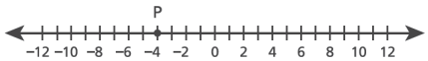

24. What is the value of the expression below?
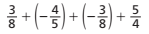

25. The table shows prices for shoe rental, games, and snack at the bowling alley.
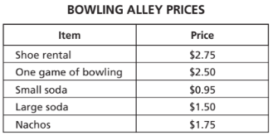
Gina rented shoes, bowled 3 games, and bought 1 order of nachos. She used a coupon for$\frac{1}{2}$off the price of her bowling games. What was Gina's total cost?
26. Amber determined that the expression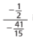is the equivalent to $\frac{15}{82}$. Which statement describes the process Amber could have used?
27. Which of these multiplication expressions is equivalent to the division expression below?
$-\frac{4}{23} ÷ \frac{7}{58}$
28. What is the value of the expression below?
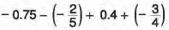
29. What is the value of the following expression?
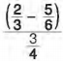
30. What is the value of the expression?
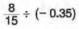
31. What is the value of the expression below?
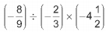
32. The table below shows the weekly change in the price of one gram of gold for four weeks.
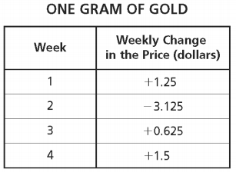
By how much did the price of one gram of gold change from the beginning of week 1 to the end of week 4?
33. Which of the following expressions represents the distance between the two points?
34. Graham's monthly bank statement showed the following deposits and withdrawals:
-$25.20, $52.75, -$22.04, -$8.50, $94.11
If Graham's balance in the account was $47.86 at the beginning of the month, what was the account balance at the end of the month?
35. Evaluate the expression below. -2 ¼ + 8 + (-1 ¾)

